Key points of a budget analysis:
- Define objectives
  - Increasing brand awareness

- Identify key areas for investment
  - All the different types of areas in which we want Mobisec to increase brand awareness

- Check your budget against the forecast
  - Prioritize the identified areas based on their potential impact on achieving objectives

- Allocate a portion of the budget to each area
  - Prioritize the identified areas based on their potential impact on achieving objectives
Focusing more individually:
- Marketing and Brand Awareness
  - Invest in targeted marketing strategies, both online and offline
  - Allocate funds for social media advertising, content creation and SEO to enhance online visibility

- Events and Collaboration
  - Allocate budget for participating in industry events, trade fairs, and conferences.
  - Consider collaboration opportunities with universities, research institutions, and industry partners.

- Online Presence
  - Optimization of a professional website (improving the existing ones)
  - Allocate budget for online advertising and sponsored content on relevant platforms

- Product Development
  - If applicable, allocate funds for research and development of new products or features which can attract even more customers (e.g. consulting/support
  - Consider investing in cybersecurity training programs or resources.

- Metrics and Analysis
  - Allocate a portion of the budget for analytics tools to measure the impact of marketing campaigns and online presence.
  - Invest in market research to track industry trends and competitor activities.

- Flexibility, Review and Adjust (Benchmarking)
  - Reserve a portion of the budget for unforeseen expenses or opportunities that may arise during the execution of the plan.
  - Regularly review the budget allocation and assess the performance of each investment area.

Let’s first start on how the communication should be brought up:
- Using social media and ad campaigns in order to get Mobisec noticed
  - Both video/blog/articles in sectorial news/newsletters/email marketing
- Participating to fairs and attract new companies in sector fairs, both cybersec and innovation
- Collaboration with local universities to raise awareness and collaborate between students and professor, possibly involving them in projects
- Do formations and seminars on cybersecurity themes in order to attract new people
- Speak at events/TEDs/talks to raise new interest in these topics
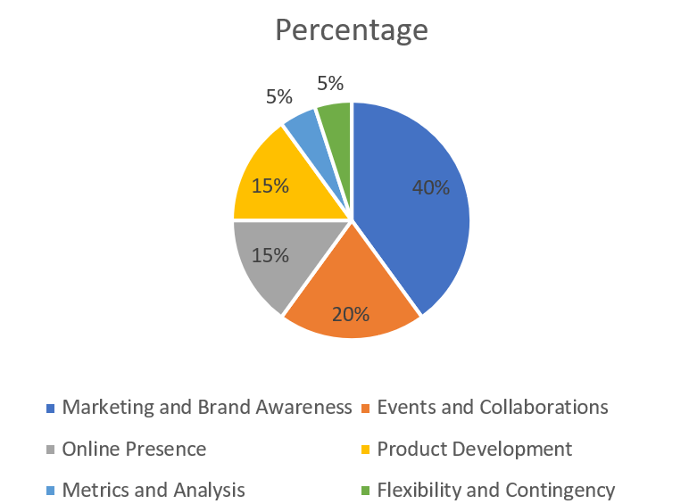
This is hypothetically the allocation, considering the budgeting should have a part of the team dedicated to account for budget changes, to establish policies, distributions and activities:

We should consider:
- Identify periods of time and spending requirements
- Identify internal expenses and quantify them on how much to spend for marketing and communications (so-called “variable expenses”)
- Determine methods of funding/partners/possible investors
- Set constraints and effective methods of analysis
Considering the Mobisec revenue: 688.281,00€ as of 2022. Given the data above (common, in this sector to allocate 15-20% of revenue for marketing and communication), we can define:
1. Social Media and Ad Campaigns (40%):
- Total Budget: €40,000
- Breakdown:
  - Video/Blog/Articles: €15,000
  - Sectorial News/Newsletters/Email Marketing: €25,000

2. Participating in Fairs (20%):
- Total Budget: €20,000
- Includes booth setup, promotional materials, and travel expenses.

3. Collaboration with Universities and Projects stakeholders (15%):
- Total Budget: €15,000
- Covers expenses for seminars, workshops, and collaborative projects.

4. Formations and Seminars (15%):
- Total Budget: €15,000
- Includes expenses for venue, materials, and instructor fees.

5. Speaking Engagements (10%):
- Total Budget: €10,000
- Covers travel expenses and any fees associated with event participation.

General Considerations:

- Internal Expenses (5%):
  - Total Budget: €5,000
  - Internal expenses related to budget management, policy establishment, and team coordination.

- Variable Expenses (5/10%):
  - Total Budget: €5,000/10.000
  - Set aside for unexpected variable expenses.

- Budget for Analysis and Adjustments (5%):
  - Total Budget: €5,000
  - Reserved for ongoing analysis, adjustments, and feedback loops.

Revenue Allocation:
- Revenue Allocation for Marketing and Communications:
  - For example, if revenue is €688,281, allocate 15-20%, i.e., €103,242 - €137,656 for marketing and communications.

Consider at this phase:
- Return on Investment (ROI)
- Testing and Iteration
- Competitor Analysis

